

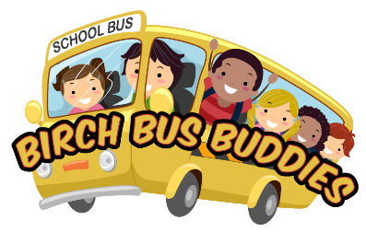

Field Trips to Hugh Taylor Birch State Park

Please complete this form and return it to Michelle Schmitz, mschmitz@birchstatepark.org

The school will be responsible to book the school bus. friends of birch state park will make a donation to the school to reimburse the bus expense. a letter (on letterhead) from the school principal explaining the educational significance is required to have park admission fees waiveD. Please submit the letter to the email above along with final headcounts, at least 2 weeks prior to the field trip.

school information:
Name:
Address:
Principal Name: | Principal Phone Number:
Grade Level attending Field Trip:
Approximate # of Students: Approx. # of Staff/Chaperones:
Day of Contact Person Name:
Day of Contact Phone Number: Day of Contact Email:
Requested Field Trip Dates:
How does this field trip collate with your curriculum:
Are you interested in incorporating a Ranger Guided Program: O YES O NO

TRANSPORTATION INFORMATION: (To be completed by school staff)
Departure time: Estimated time of Park Arrival: |  | Estimated time of Park Departure:
Number of Buses Needed: Total # of Hours Bus Required:
FRIENDS WILL MAKE A DONATION TO THE SCHOOL AT A RATE OF $58 PER BUS PER HOUR.
FOR ADMINISITRATIVE PURPOSES ONLY:

Confirmed Field Trip Date: _______________________________________________________________________

- Principal letter received
- Park Manager approval
- Photo Release
- Donation to school: $_________________ Paid on:____________________________

